****

**PLACEMENT MANAGEMENT**

**SYSTEM**

***Dissertation Submitted in Partial fulfillment of the***

***Requirement for the Award of the Degree of***

***Bachelor of Computer Applications***

***Semester VI***

## Jan - June, 2023

**Under the guidance of Submitted By**

Dr. Hitesh Ninama Arun Meena (2011105)

Chetan Yadav (2011108)

Lokendra Mahale (2011216)

**School of Computer Science & IT**

**Devi Ahilya Vishwavidyalaya, Indore, M.P.**

**2023**

**DECLARATION**

I hereby declare that the project titled “Placement Management System” submitted by us for the partial fulfillment of the requirement for the award of *Bachelor of Computer Applications* to *School of Computer Science & IT, Devi Ahilya Vishwavidyalaya, Indore,* comprises my own work and due acknowledgement has been made in text to all other material used.

Signature of Student:

Arun Meena \_\_\_\_\_\_\_\_\_\_\_\_\_\_\_\_\_\_

Chetan Yadav \_\_\_\_\_\_\_\_\_\_\_\_\_\_\_\_\_\_\_

Lokendra Mahale \_\_\_\_\_\_\_\_\_\_\_\_\_\_\_\_\_\_\_

Date: \_\_\_\_\_\_\_\_\_\_\_\_\_\_\_\_\_\_

Place:

SCSIT Davv

**School of Computer Science & IT**

**Devi Ahilya Vishwavidyalaya, Indore, M.P.**

**CERTIFICATE FROM GUIDE**

It is to certify that dissertation on “Placement Management System”, submitted by Arun Meena, Chetan Yadav, Lokendra Mahale to the *School of Computer Science & IT, DAVV, Indore* has been completed under my supervision and the work is carried out and presented in a manner required for its acceptance in partial fulfillment for the award of the degree of *Bachelor of Computer Applications*.

**Project Guide**

Signature:

**Name:**

Dr. Hitesh Ninama

Prof. SCSIT,

DAVV, Indore

**Date: \_\_\_\_\_\_\_\_\_\_\_\_\_\_\_\_\_\_\_\_\_\_**

**School of Computer Science & IT**

**Devi Ahilya Vishwavidyalaya, Indore, M.P.**

**CERTIFICATE**

It is to certify that we have examined the dissertation on “Placement Management System”, submitted by Mr. Arun Meena, Mr. Chetan Yadav, Mr. Lokendra Mahale to the *School of Computer Science & IT, DAVV, Indore* and hereby accord our approval of it as a study carried out and presented in a manner required for its acceptance in partial fulfillment for the award of the degree of *Bachelor of Computer Applications*.

**Internal Examiner External Examiner**

Signature**:** Signature**:**

Name  **:** Name **:**

Date **:** Date  **:**

**Acknowledgment**

In creating our project, we had to take the help and guidance of some of our respected faculties, who deserve our greatest gratitude. The completion of this project gives us much pleasure. We would like to show our gratitude to Dr. Hitesh Ninama sir for giving us guidance for project and discussions. We would also like to thank everyone who have directly and indirectly guided us in developing this project. In addition to this, we would like to thank our respected faculty and project coordinator Mr. Pankaj Jagtap sir, who introduced us to the documentation of project management. During this journey, we faced numerous unforeseen problems and unknown challenges. Many people met us during this endeavor and enriched us with their support and knowledge both personally and professionally which resulted in the project being better than it could possibly have been without them.

Many people, especially our classmates and team members themselves, have made valuable comments and suggestions on this proposal which inspired us to improve our project. We thank all the people for their help to complete our project.

**CONTENTS:**

1. Title page

2. Declaration

3. Certificate from Guide

4. Acknowledgement

5. Abstract

Chapter 1: Introduction

Chapter 2: Analysis

Chapter 3: Project Planning

Chapter 4: System design

Chapter 5: System Implementation Methodology

Chapter 6: System Implementation

Chapter 7: System Testing

Chapter 8: Output Form & Reports

Chapter 9: Limitations

Chapter 10: Conclusion

**CHAPTER I**

**INTRODUCTION**

This project is based on web application for the Placement Management System. This system is a web application that can be access throughout the organization with proper login provided. The key feature of this project is that it is a onetime registration. Our project provides the facility of maintaining the details of the students. This project is to facilitate students in college and company to register. The user can access easily to this and the data can be retrieved in no time. In the main page there are options for a new register, a registered student can directly login using user name password. In the student registration form we can give the personal details, educational, qualifications, technologies.

**1.1 Aim-**

Our aim is to design Placement Management System.

**1.2 OBJECTIVE-**

The objective of the project is to explain and elaborate the concept of “Placement management system” to the students and company, hence providing a reliable and efficient platform to assist them to afford it without much trouble.

**1.3 SCOPE-**

**Scope of project:**

 Our project has a big scope to do. Students can access previous information about placement. We can store information of all students. Various companies can access their information.

1. Easy to collect and manage student data.

2. To increase the accuracy and efficiency of placement procedure.

3. Reduce the paper work.

4. Analysis of overall place

**CHAPTER II**

**ANALYSIS**

**2.1 Business needs**

The main aim of the project is to give a suitable platform to our college (SCSIT) for placement management preparation. The platform where any eligible student can upload their details.

We as a developer try our best and make a website and keep all these things in mind and present all these functionalities in the project.

**2.2 Functional Requirements**

A functional requirement defines a function of the system and its components. A function is described as a set of inputs, the behaviour and its outputs.

The main purpose of functional requirements within the requirement specification document is to define all the activities or operations that take place in the system. These are derived through interactions with the users of the system.

1)This project should register all the placement eligible student.

2) This project should register all the placement recruiter.

3) This project should create a database of students and companies for college purposes.

**2.3 Non-Functional Requirements**

A non-functional requirement is a requirement that specifies criteria that can be used to judge the operation of a system, rather than specific behaviours. Non - Functional Requirements are often called qualities of a system.

Following are the non-functional Requirements of placement management system:

**Usability**

* We get the responses within the seconds.
* The web application has a simple, user friendly interface so users can save time and confusion.

**Reliability**

* The website is more reliable because of the qualities that are inherited from the platform. The code built by using PHP, HTML and CSS is more reliable.

**Interface**

* The user interface is based on the web browser. The website is built using PHP, HTML and CSS .
* The interface design is aimed at a flexible front-end communication to provide the user with clear information in navigating a user-friendly interface is planned.

**Security**

* It will allow to changes and updates only by admin.

**CHAPTER III**

**PROJECT PLANNING**

Project planning is part of project management, which relates to the use of schedules such as charts to plan and subsequently report progress within the project environment. In project planning, we define what is our goal of the project, the durations for the various tasks necessary to complete the work are listed and grouped into a work breakdown structure. Project planning is often used to organize different areas of a project, including project plans, workloads, and the management of teams and individuals.

Software project plan can be viewed as the following:

1)Within the Organization:

How the project is to be implemented? What are various constraints (time, cost, staff)? What is market strategy?

2)With respect to the customer:

Weekly or timely meetings with the customer with presentation on status reports.

**Project Goals:**

The goal of Placement management system is to automate the existing manual system by the help of computerized equipment and full-fledged computer software, fulfilling the requirements, so that their valuable data/information can be stored for a longer period with easy accessing and manipulating of the same .The required software and hardware are easily available and easy to work with.

**Requirement:**

**2.1 Hardware Requirements**: -

* i3 Processor
* 4GB RAM
* 512 KB Cache Memory
* Hard disk 10 GB
* Microsoft Compatible 101 or more Keyboard.

**2.2 Software Requirements: -**

* Operating System: Windows
* Programming language: HTML
* Designing: CSS
* Front-End: HTML
* Back-End: PHP
* Server: Xampp server and localhost

**Existing System**

All processes in existing system are handled manually. All the work that is done in the existing system is done by the human intervention. As all the work is done manually, there were a lot of work load on placement officer and it also increases the maximum chances of errors. This is so slow and time consuming. Due to increase in

number of user’s the process become more difficult. Problems faced in existing

system are as follows-

• Searching of eligible students is done manually by TPO based on the company

criteria.

• The records were stored in modified excel sheets hence sorting problem.

• The duplication of records was usual hence data redundancy.

• TPO’s have to collect all the information.

• It takes too much time to managing, updating and informing specific student for

specific company criteria.

**Proposed System**

The main purpose of proposed Web based Placement portal is meant to give more easiness to TPO, Placement coordinators and Students that they can modify and access information so quickly. The system provides a better way to maintain students information in the database, ensures data correctness and data integrity as well. The system also reduces the paperwork time and provides an efficient information flow between different system module.

**CHAPTER IV**

**SYSTEM DESIGN**

In this phase, a logical system is built which fulfills the given requirements. Design phase of software development deals with transforming the clients requirements into a logically working system. Normally, design is performed in the following two steps:

1)Primary Design Phase:

In this phase, the system is design at a block level. The blocks are created on the bases of analysis done in the problem identification phase. Different blocks are created for different functions emphasis is put on minimizing the information flow between blocks. Thus, all activities which require more interaction are kept in one block.

2)Secondary Design Phase:

In the secondary phase the detailed design of every block is performed.

The general tasks involved in the design process are following:

1. Design various blocks for overall system processes.
2. Design smaller, compact and workable modules in each block.
3. Design various database structures.
4. Specify details of programs to achieve desired functionality.
5. Design the form of inputs, and output of the system.
6. Perform documentation of the design.

3) ER Diagram

**LOGIN**

**STUDENT**

**RECRUITER**

**ADMIN**

**2)Data Flow Diagram:-**

**COMPANY**

**database**

**ADMIN**

**Get Details**

**Edit Details**

STUDENT

**Student Details**

Data Flow Diagram :
LOG IN
0.2.1
VIEW PROFILE
HOME
0.2.2
ADMIN LOGIN_DB
ADMIN PROFIE_DB
ADMIN
ENTER LOGIN
DETAILS
INVALID
...

Admin

Admin

Data Flow Diagram :
Login
0.1.1
Register
0.1.2
View
profile
0.1.3
STUDENTPROFILE_DB
STUDENTLOGIN_DB
Student
Data store
LOG...

Student

s

Student

**Data Flow Diagram :
Login
0.1.1
Register
0.1.2
View
profile
0.1.3
STUDENTPROFILE_DB
STUDENTLOGIN_DB
Student
Data store
LOG...**

**(COMPANY)**

Company

s

Company

s

Company

s

**CHAPTER V**

**SOFTWARE DEVELOPMENT METHODOLOGY**

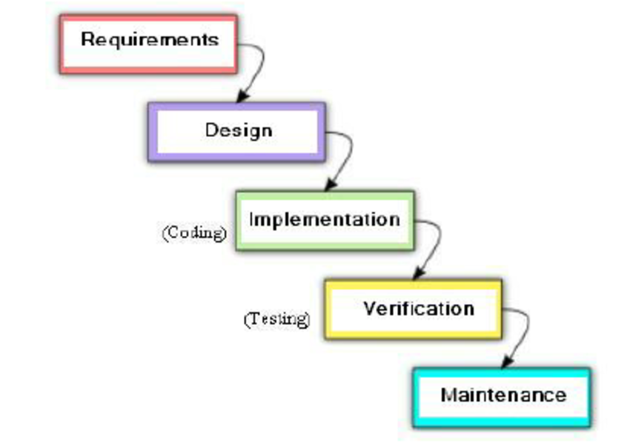

**CHAPTER VI**

**SYSTEM IMPLEMENTATION**

System Implementation is a process of implementing the idea that we analyze for the proposed system. The system we proposed needs a technology through which we can design and develop it efficiently. However, to achieve this, we create dynamic web pages, Xampp Server and for database, we use PHP for backend and HTML, CSS for designing web pages.

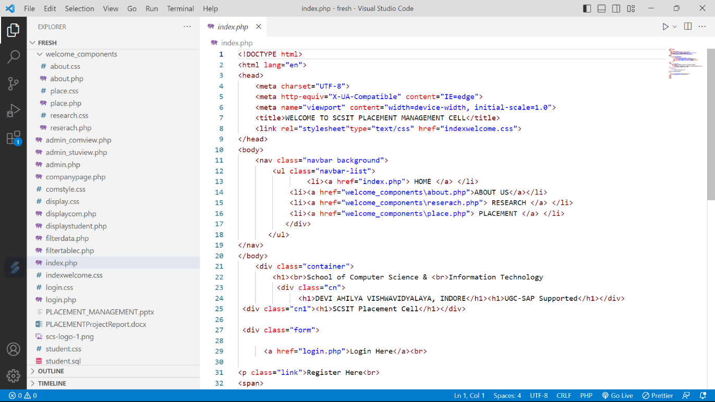

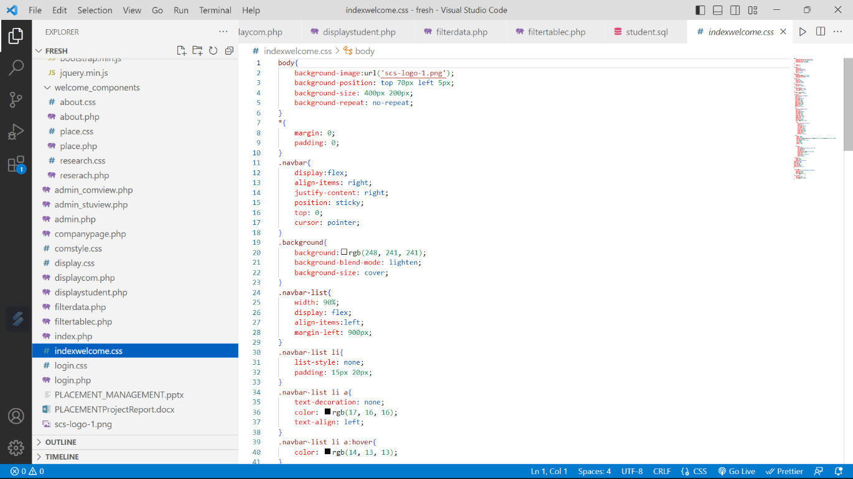

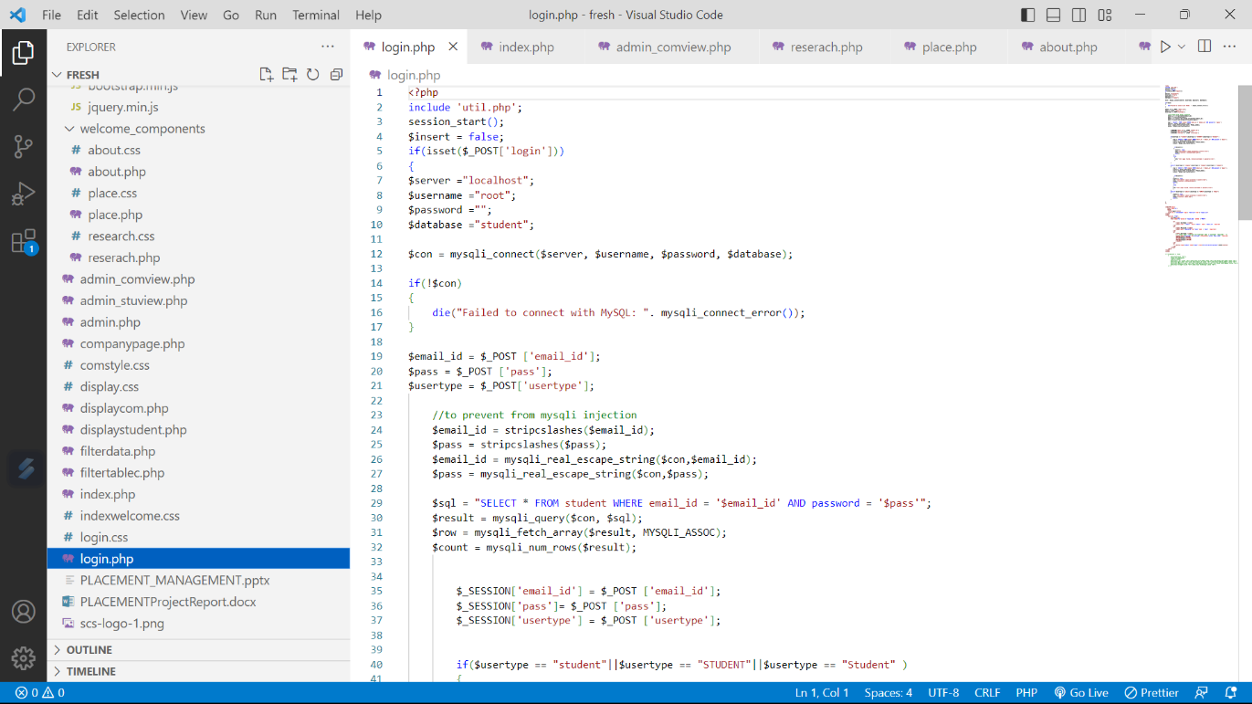

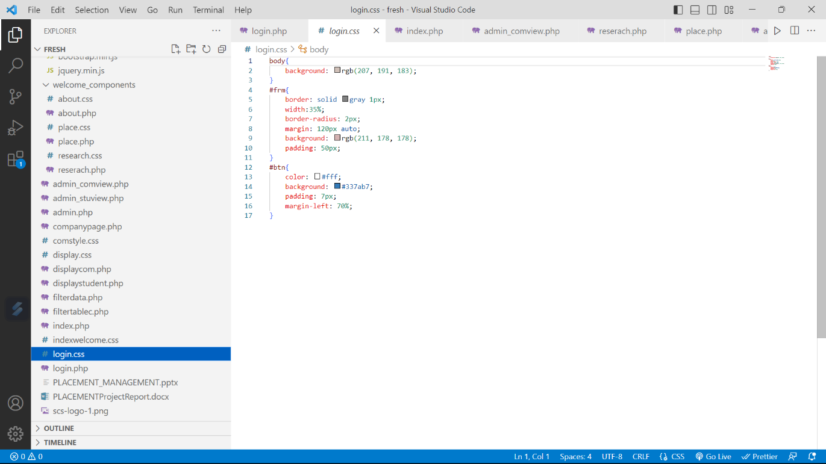

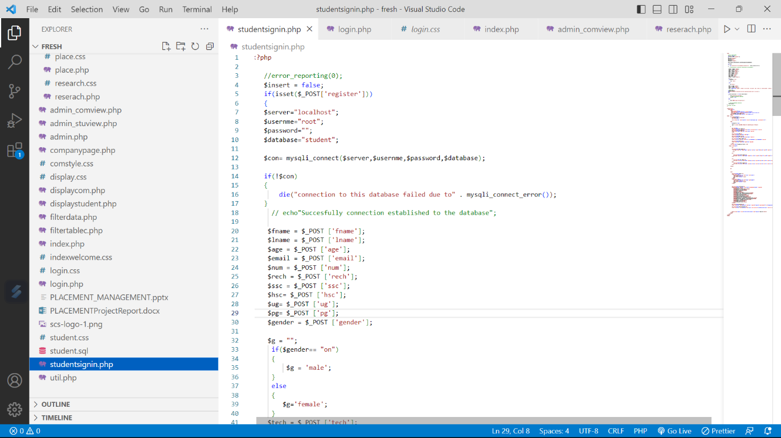

**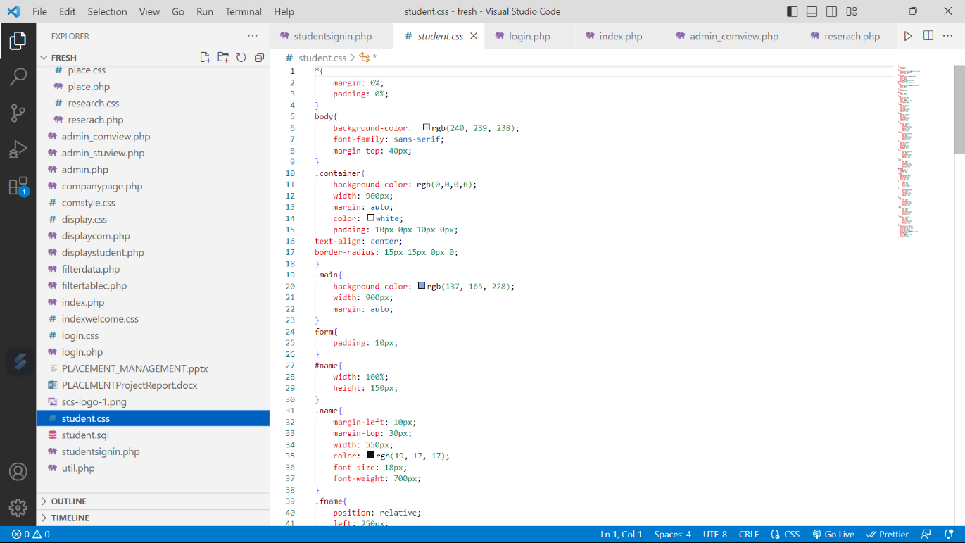**

**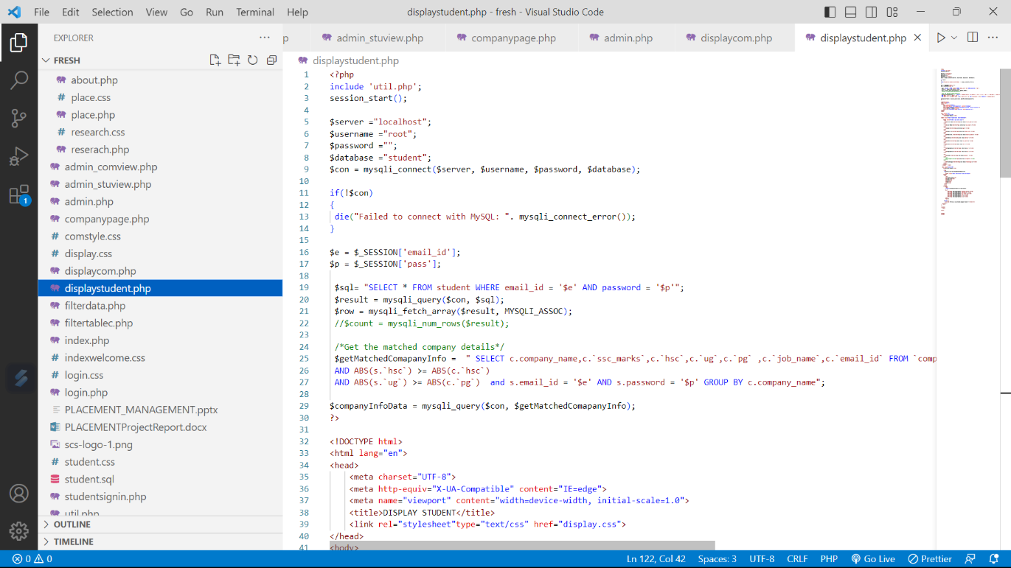**

**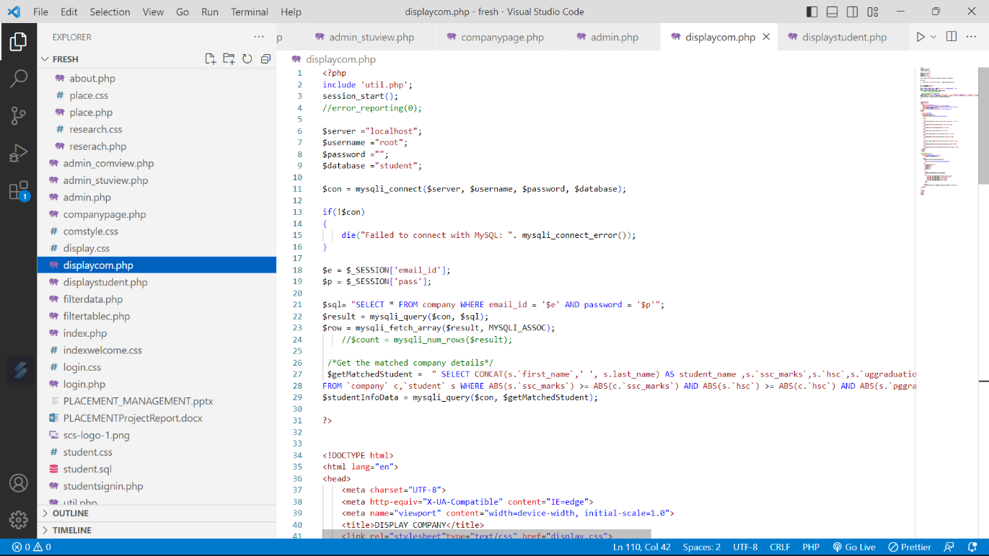**

**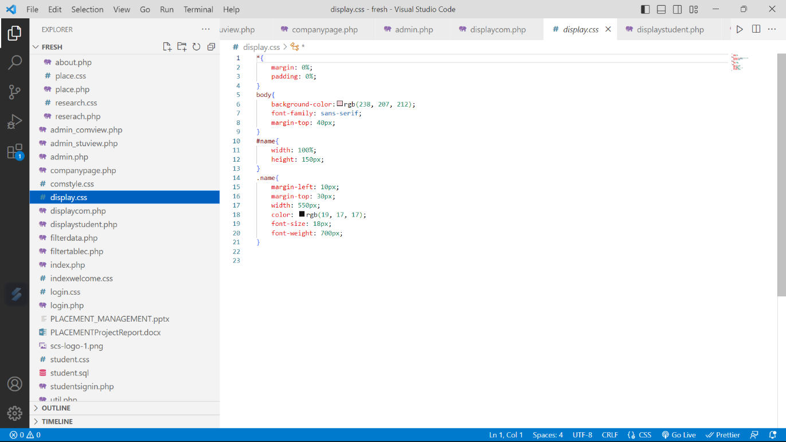**

**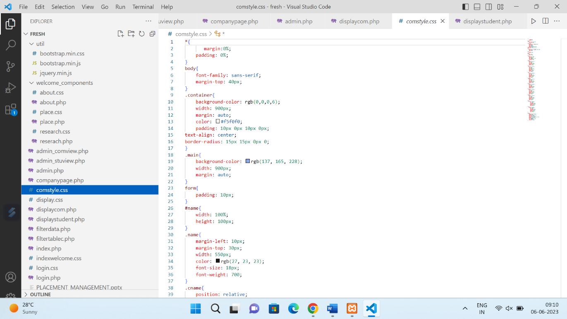**

**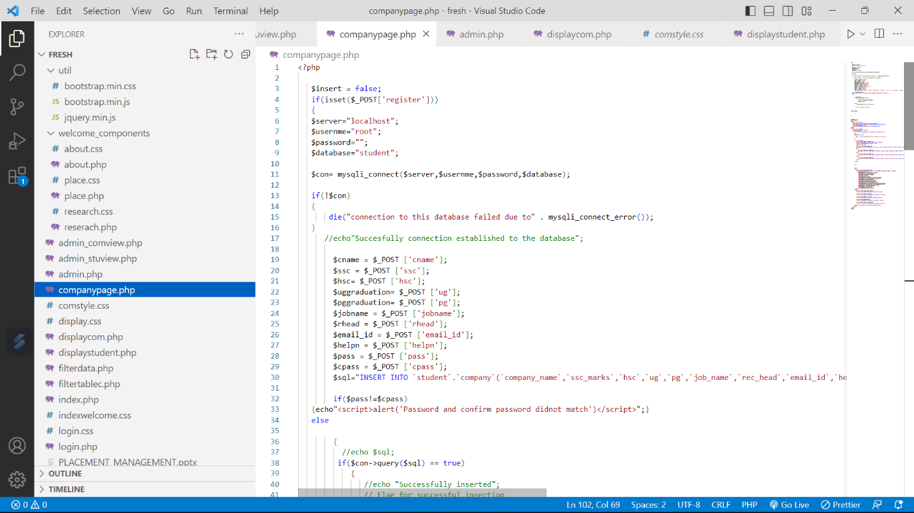**

**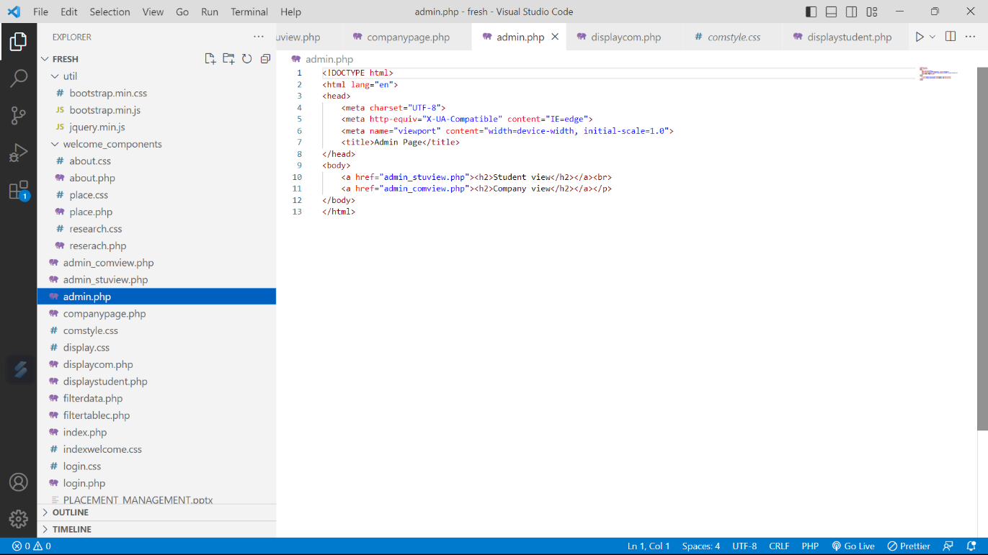**

**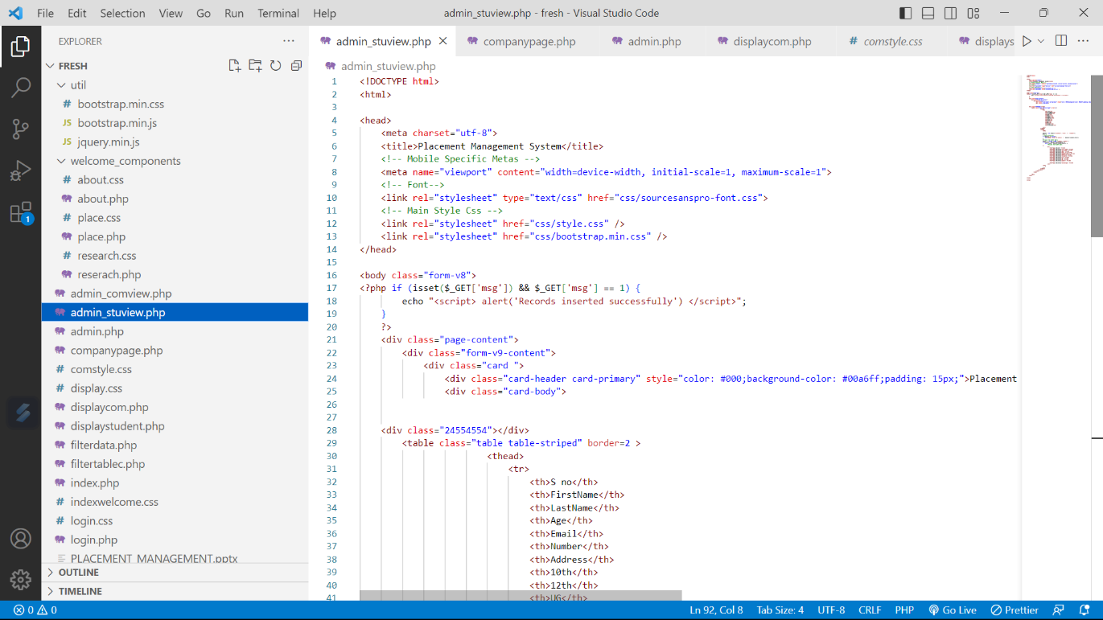**

**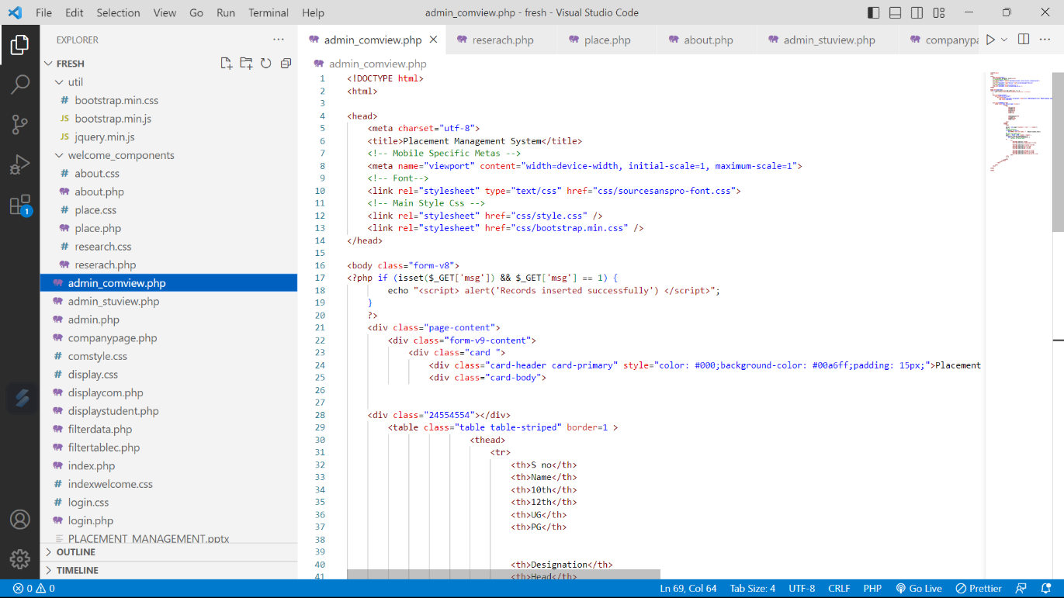**

**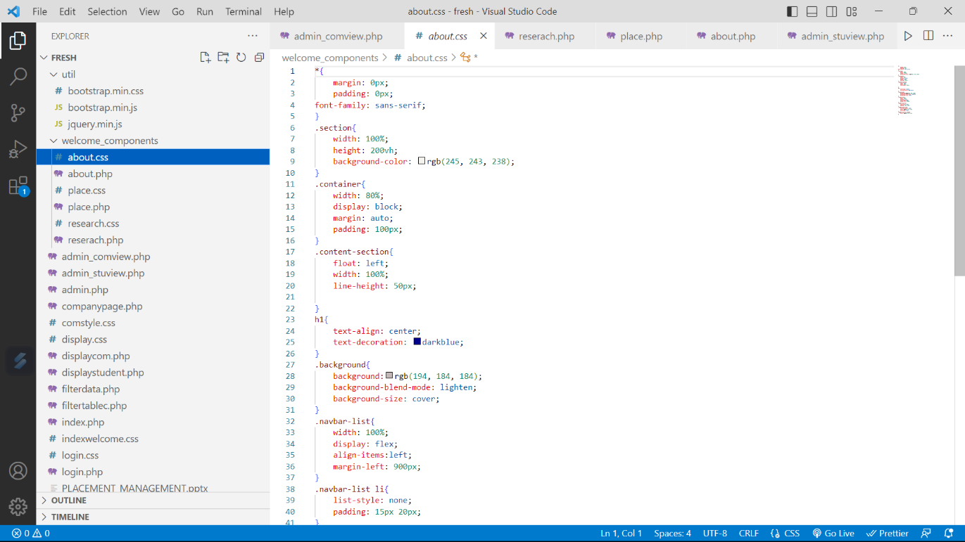**

**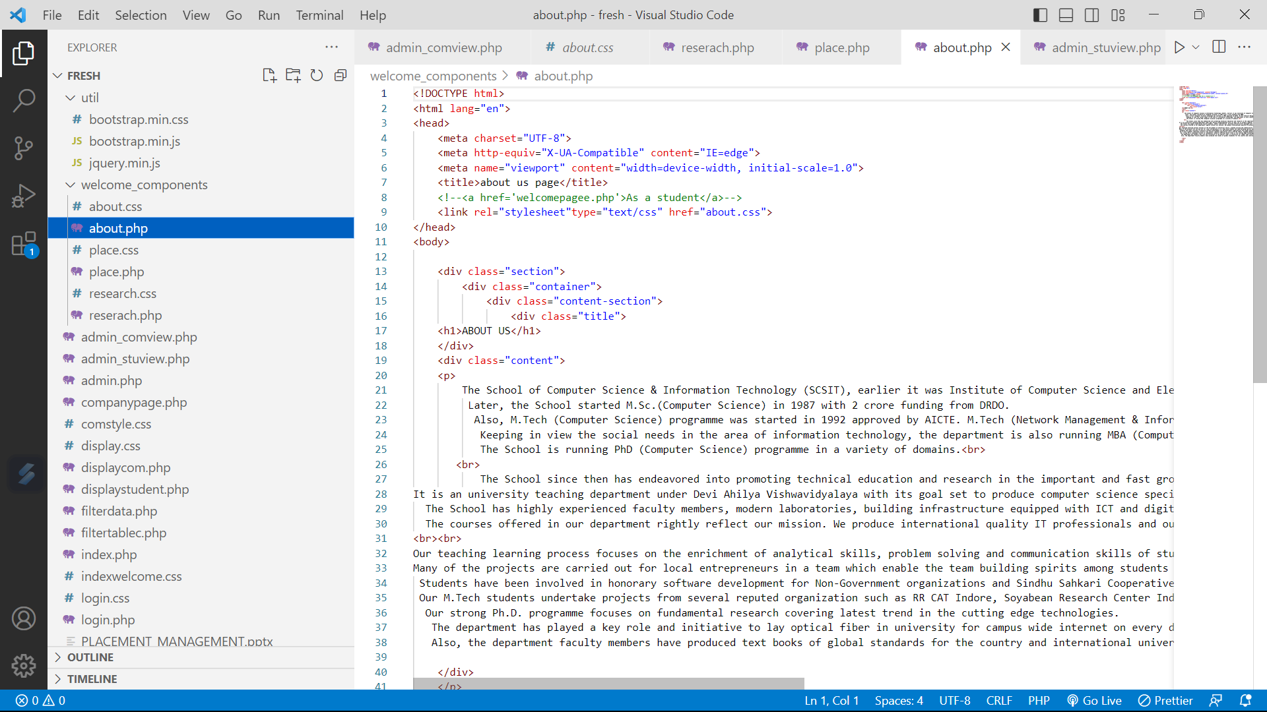**

**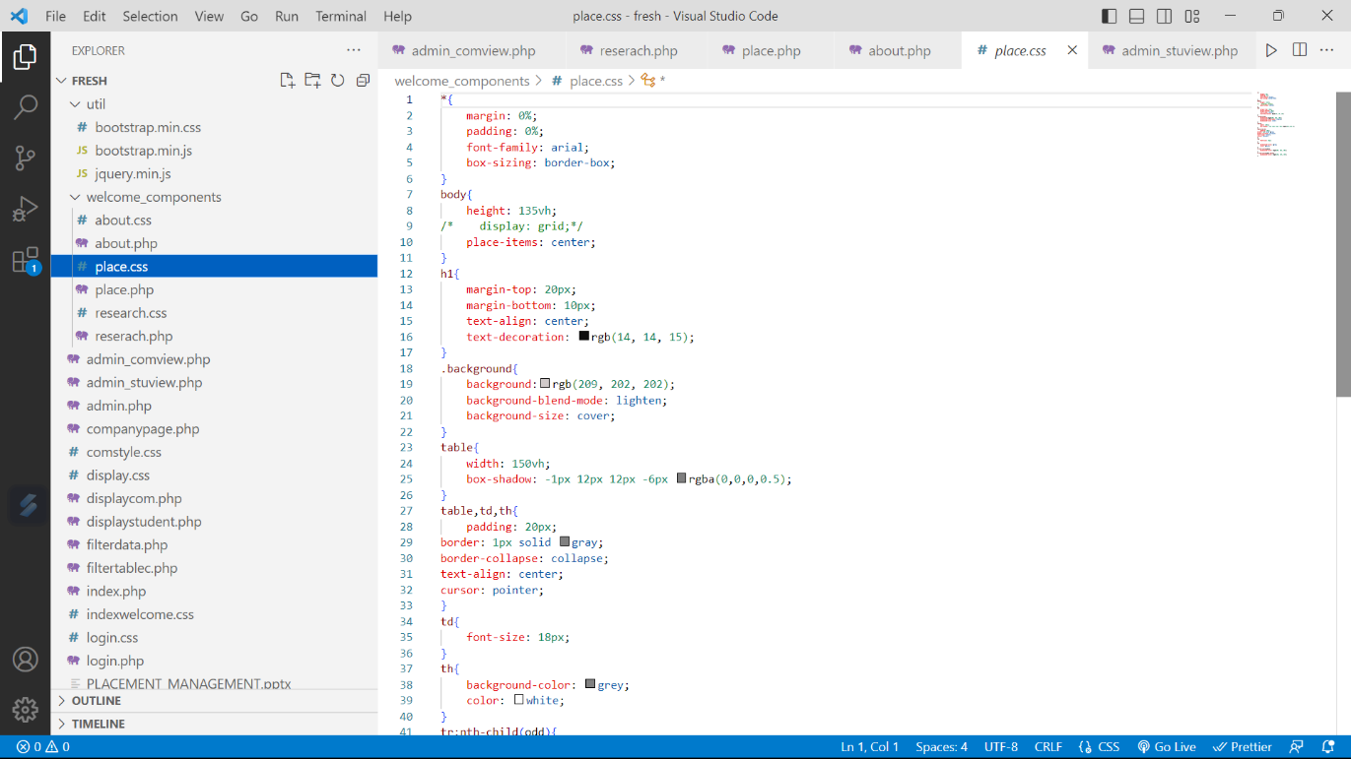**

**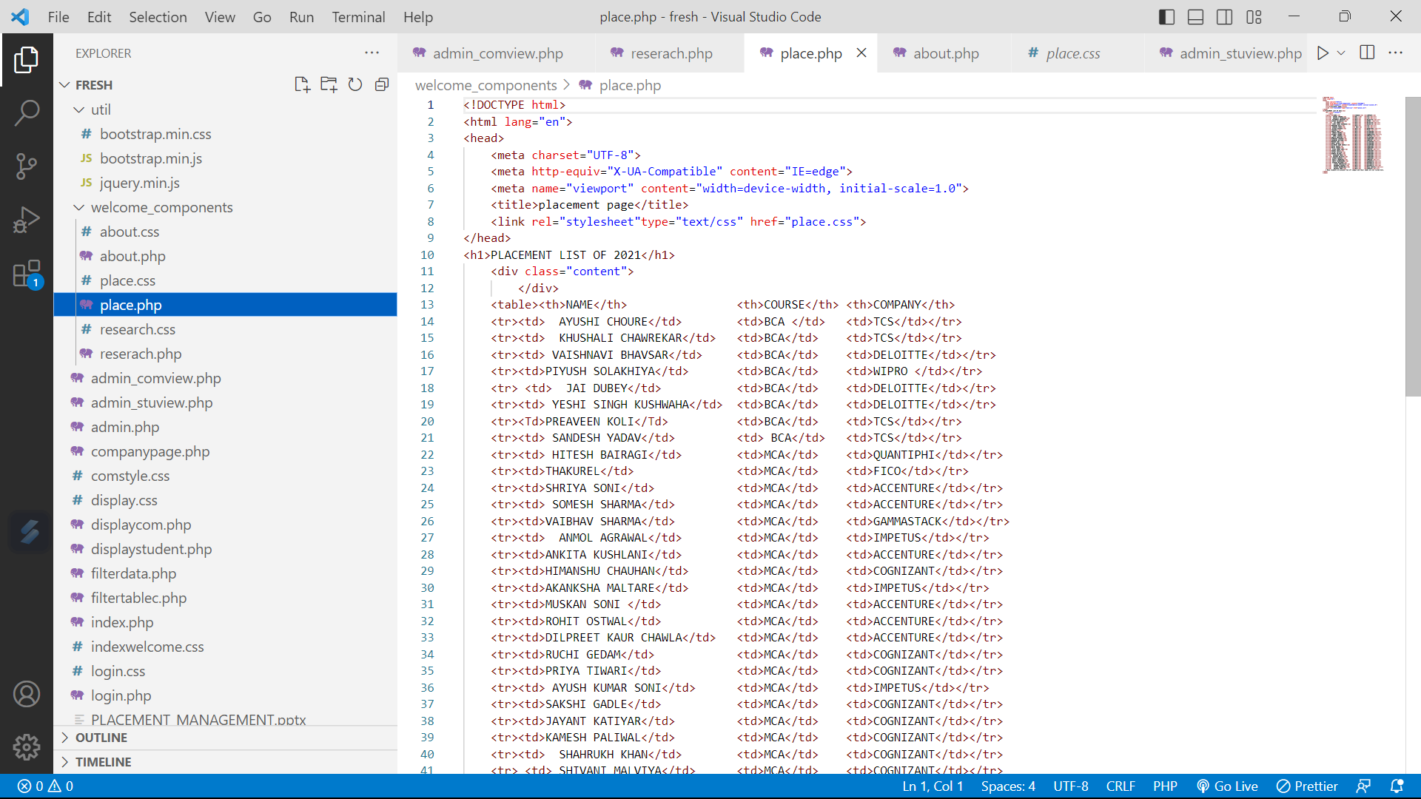**

**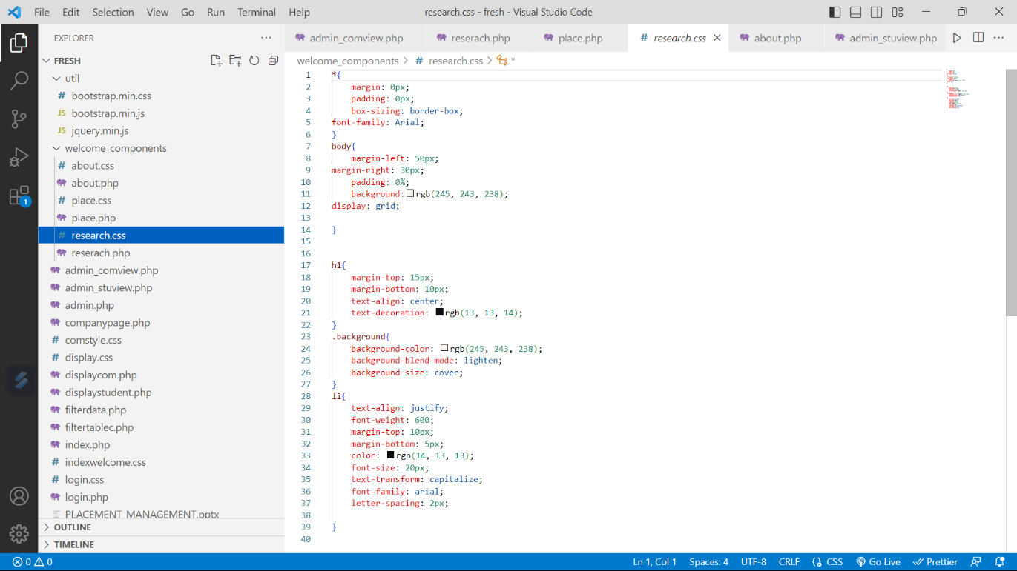**

**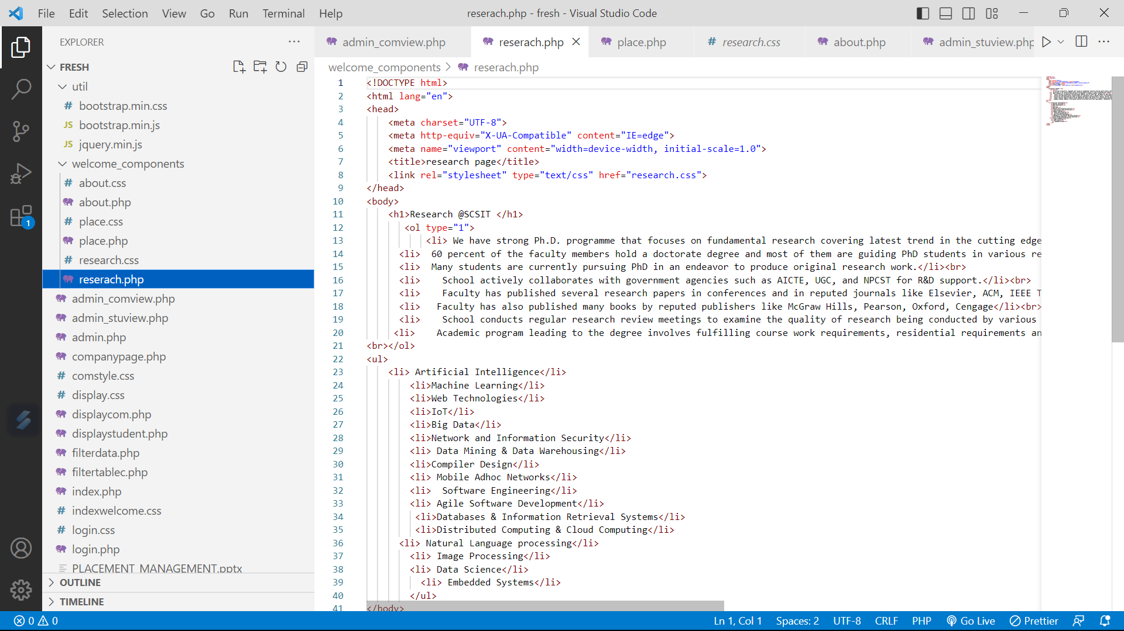**

**Chapter VII**

**SYSTEM TESTING**

**7.1. Introduction**

Once source code is implemented, software must be tested to uncover (and correct) as many errors as possible before the user uses the website. Our goal is to design a series of test cases that have a high likelihood of finding errors. To uncover the errors software techniques are used.

**1. Unit Testing:**

Unit Testing is defined as a type of software testing where individual components of a software are tested.

Unit Testing of software product is carried out during the development of an application. An individual component may be either an individual function or a procedure. Unit Testing is typically performed by the developer. It is a testing method using which all independent modules are tested to determine if there are any issue by the developer himself.

The unit testing is implemented in every module of the Placement Management website, by giving correct input to all the modules of the website. If you want the required module. If anyone want any module of the project to use and get output by giving any input from the end-user if the input is wrong and not valid then a notification appears to show the format of the input.

**CHAPTER: VIII**

**OUTPUT**

**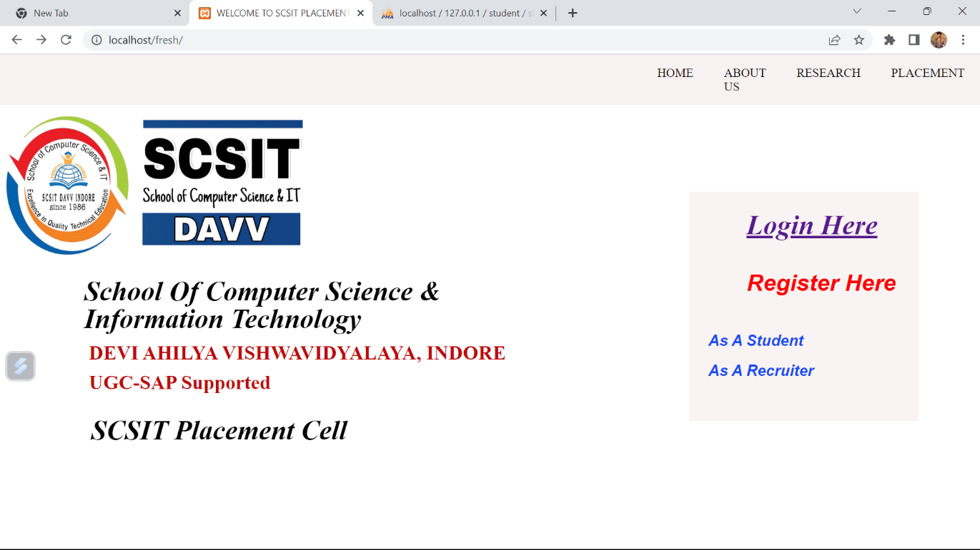**

**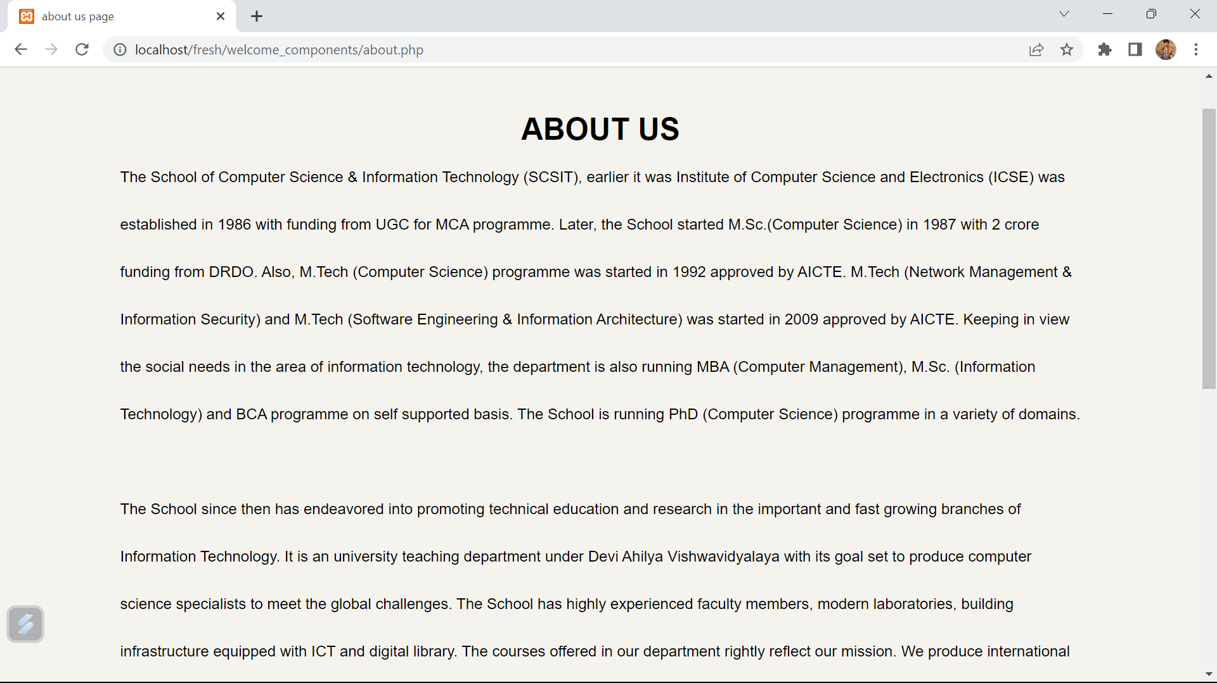**

**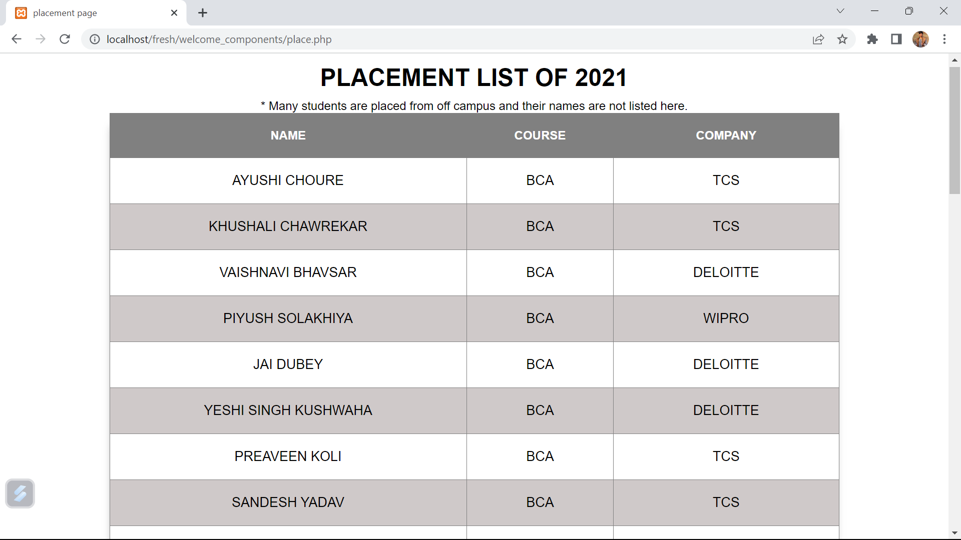**

****

**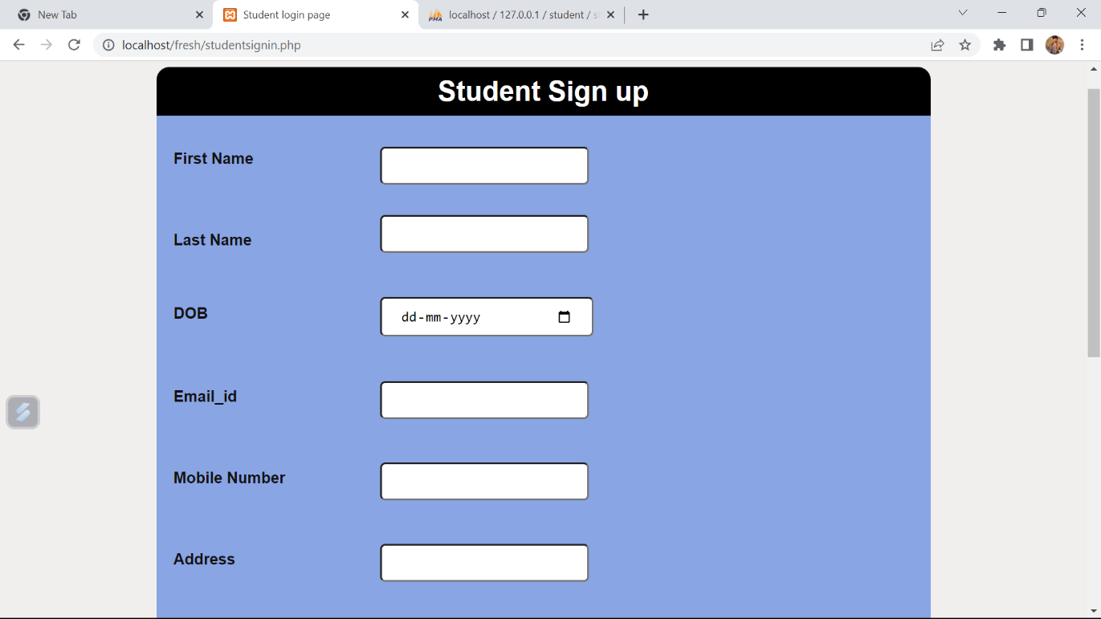**

**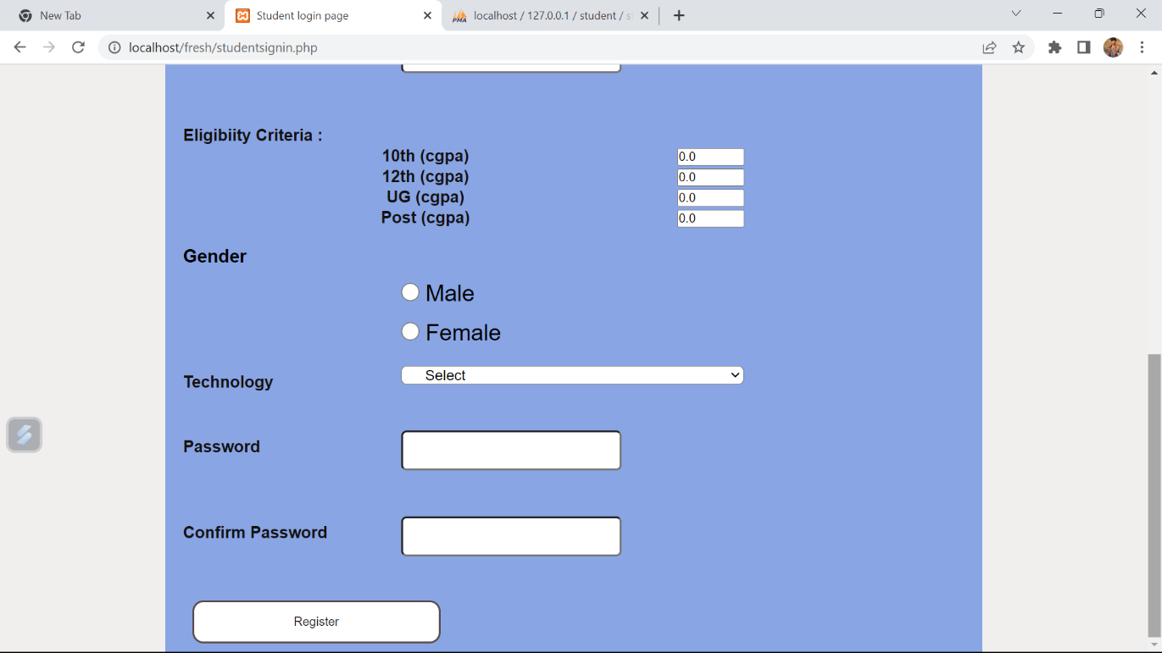**

**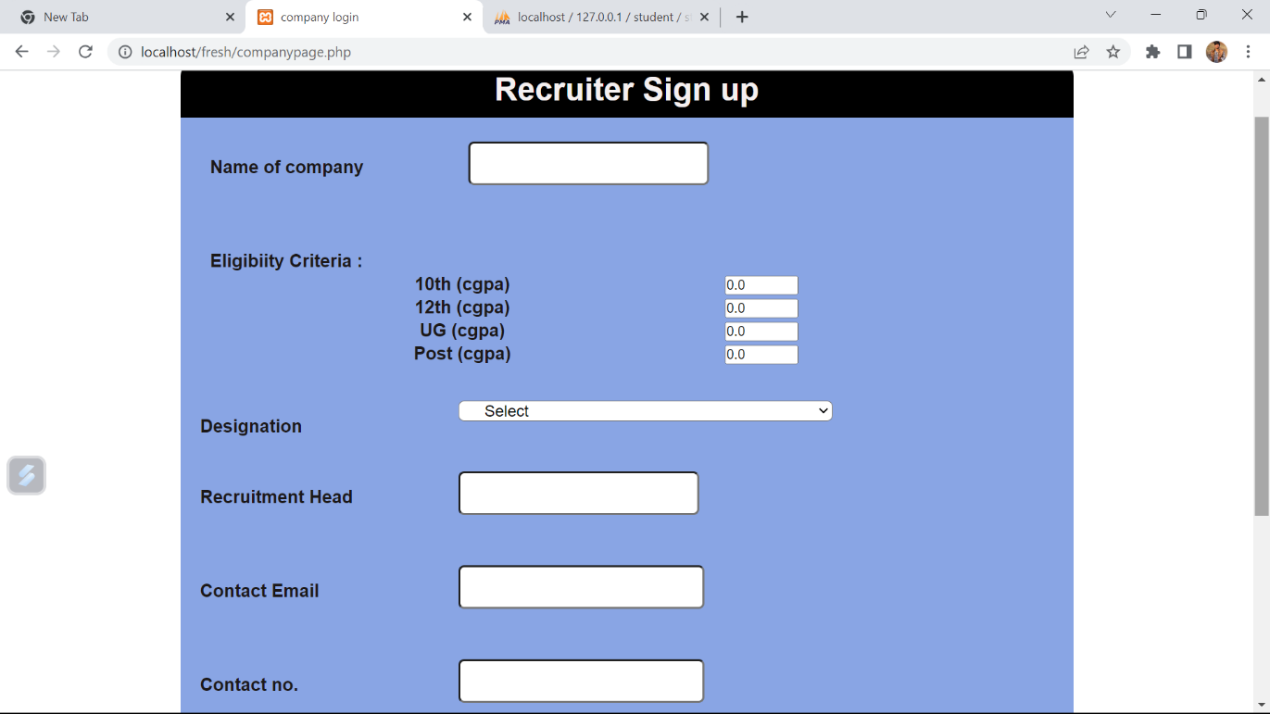**

**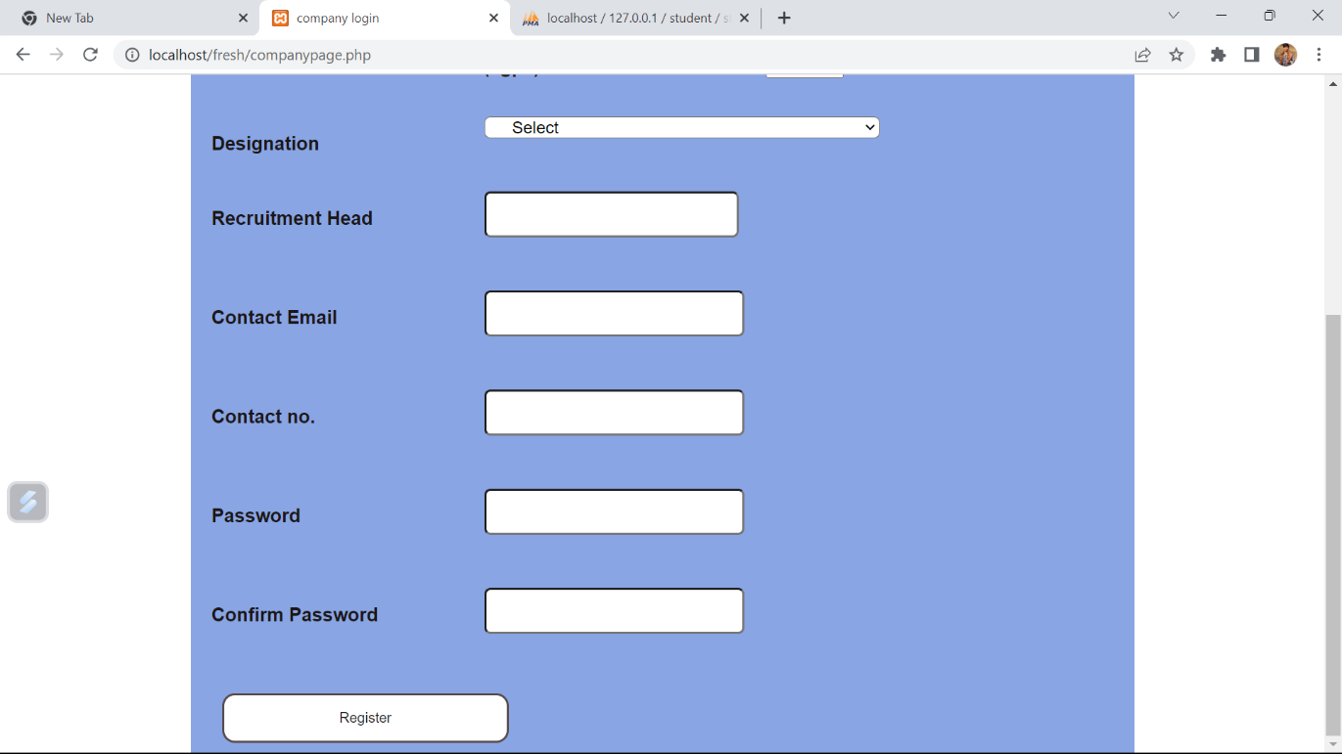**

**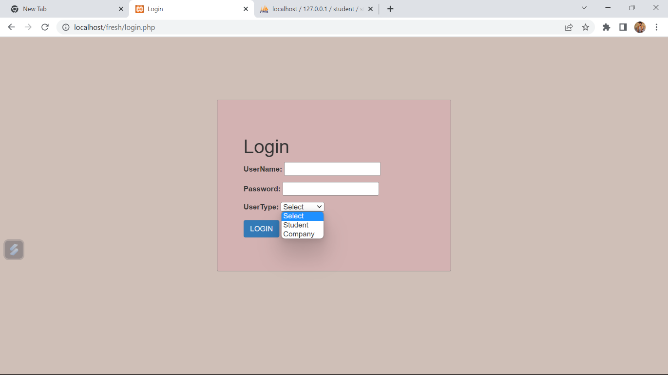**

**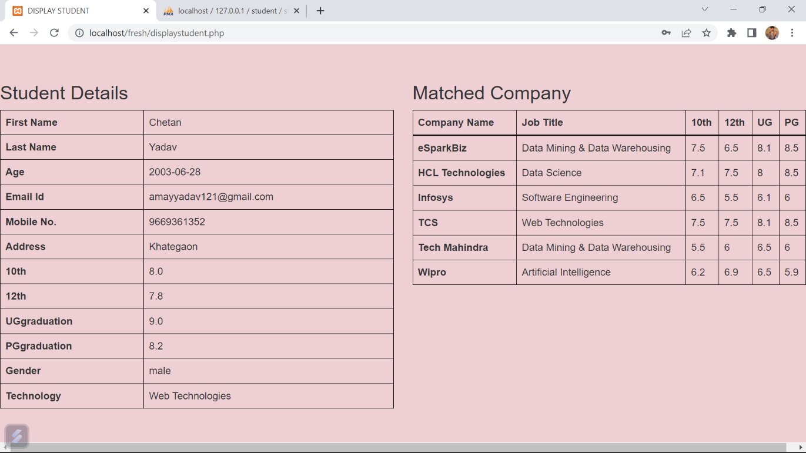**

**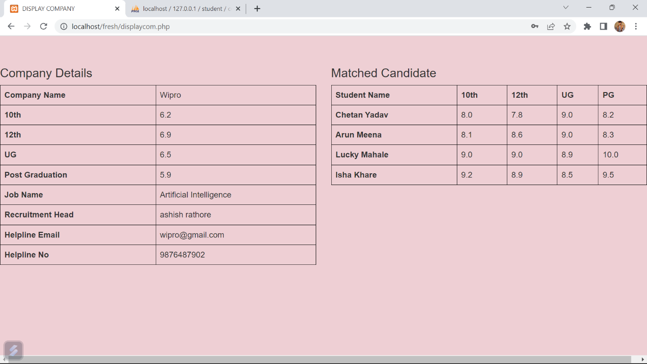**

**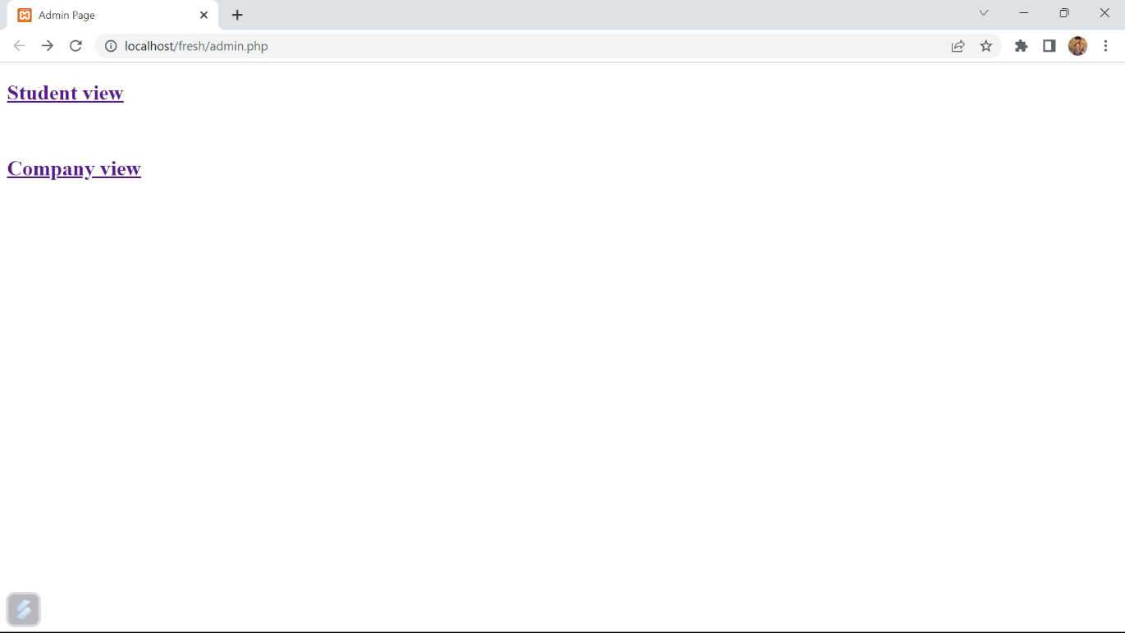**

**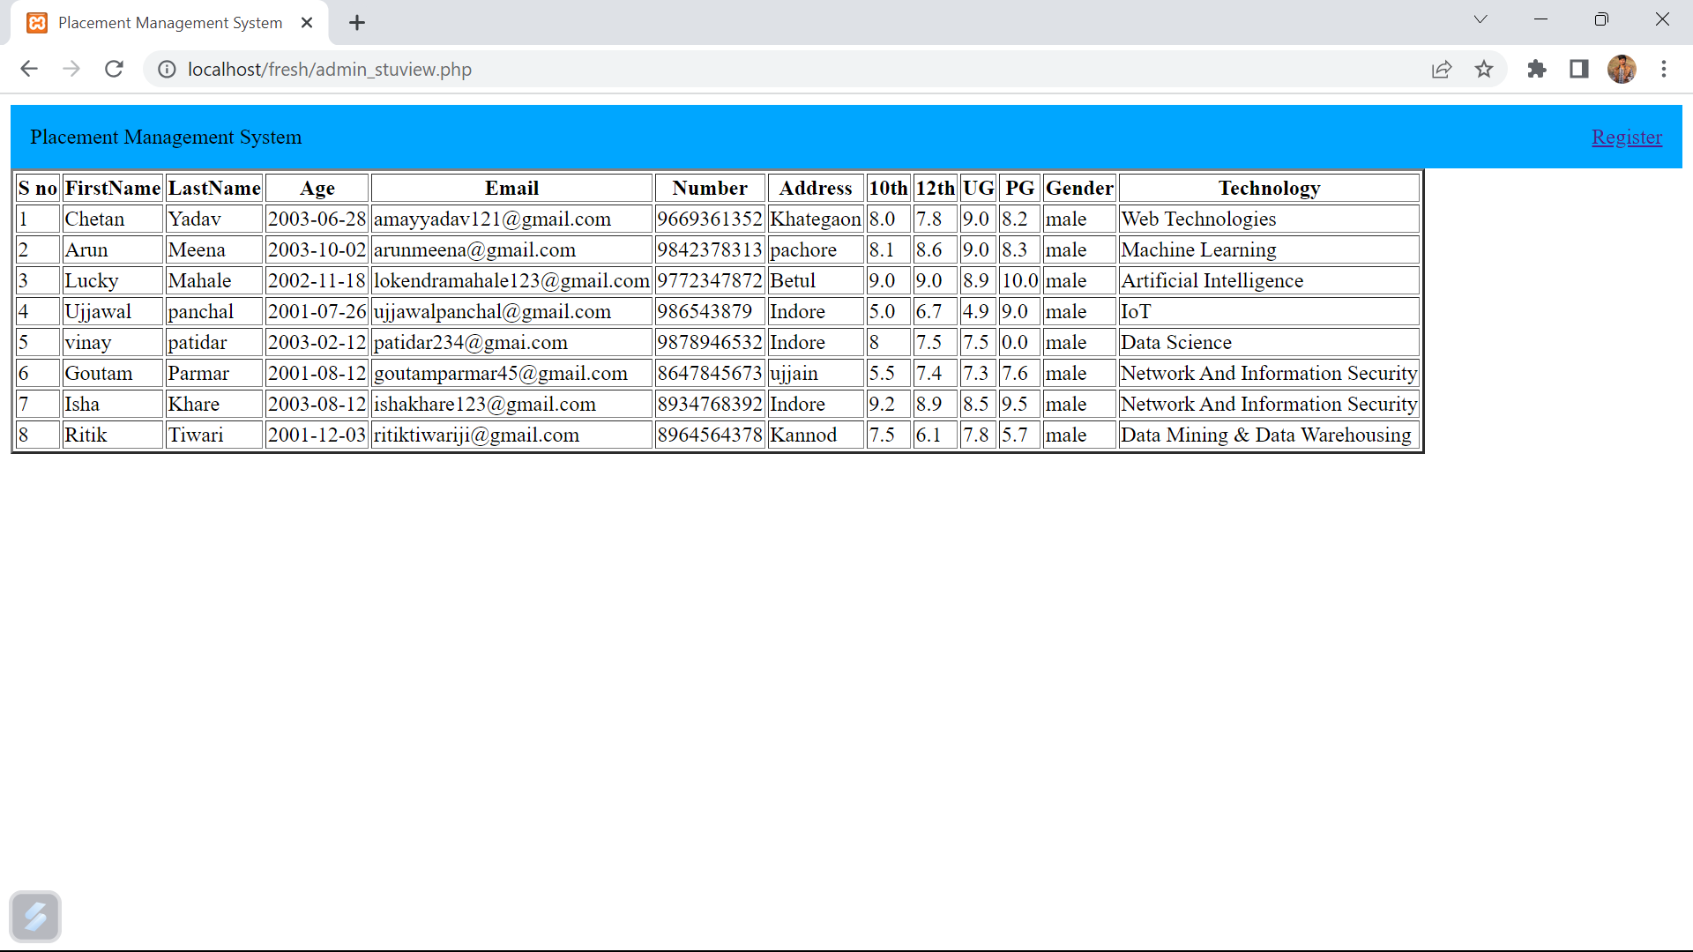**

**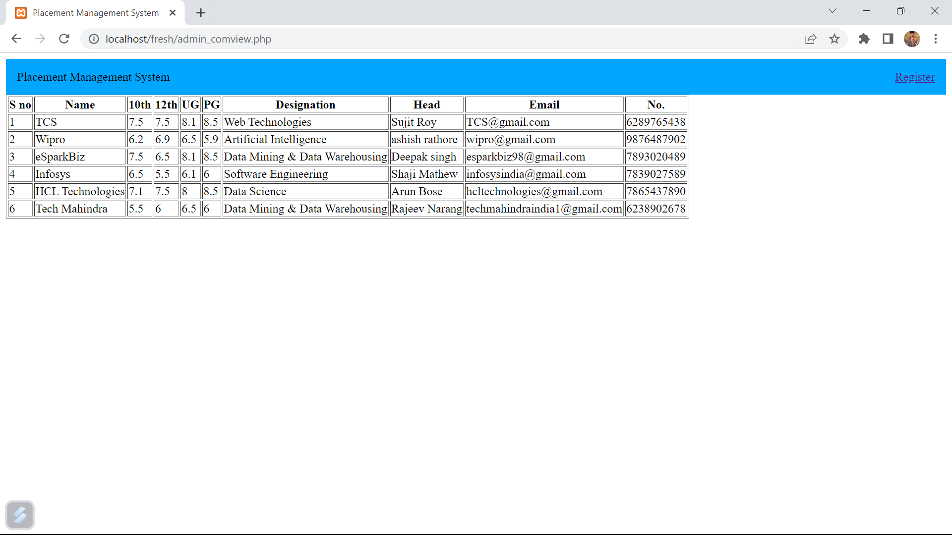**

**CHAPTER: IX**

**LIMITATIONS**

1)This project has not included login module.

2)There is no interface through which students can see registered companies.

3)This project has not included the module for application of any company.

**CHAPTER : X**

**Conclusion**

The project was designed in such a way that future modifications can be done easily. The following conclusions can be deduced from the development of the project.

(a). Automation of the entire system improves efficiency

(b). It provides a friendly graphical user interface which proves to be better when compared to the existing system.

(c). It gives appropriate access to the authorized users depending on their permissions.

(d). It effectively overcomes the delay in communications.

(e). Updating information becomes so much easier.

(f). System security, data security, and reliability are striking features.

(g). The System has adequate scope for modification in the future if necessary.